Pope Francis Signs Interfaith Climate Statement as Part of COP28 Summit in Dubai
On Sunday, Vatican Secretary of State Cardinal Pietro Parolin delivered greetings from Pope Francis at the inauguration of the faith pavilion.

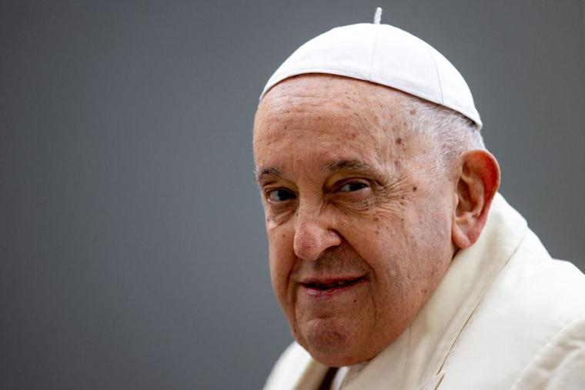Pope Francis at his general audience on Nov. 22, 2023. (photo: Daniel Ibanez/CNA / EWTN)

Daniel Payne/CAN Vatican December 4, 2023

Pope Francis has added his signature to an “interfaith statement” meant to call attention to what the Holy Father and other advocates say is the ongoing crisis of climate change threatening much of the world.

The Holy Father signed the Abu Dhabi Interfaith Statement for COP28 on Dec. 3 as part of the United Nations climate summit in Dubai. The Pope was meant to be present at the event but a respiratory illness forced him to remain in Rome rather than travel to the United Arab Emirates.

The annual summit, known as the “Conference of the Parties” (COP), is an opportunity for world leaders, representing state and nonstate actors, to meet and discuss policy goals that seek to establish common goals for climate change mitigation.
This year’s event marked the inauguration of the first-ever COP Faith Pavilion, a coalition of faith partners and others “dedicated to the engagement of faith communities” on the topic of environmentalism, according to the event’s website.

The interfaith statement signed by Pope Francis and other religious leaders expresses a “shared concern for the escalating climate impacts that imperil our cherished planet as well as our common commitment to jointly address this global crisis.”

“Our faith instills in us a sacred duty to cherish not only our human family but also the fragile ecosystem that cradles us,” the document said.

The document urges “all decision-makers assembled at COP28 to seize this decisive moment and to act with urgency” to address climate change.

It argues that the world “demands transformative action” to keep average global temperatures from warming 1.5-degrees Celsius (2.7 degrees Fahrenheit) above pre-industrial levels by the year 2100. The document also calls for “fast-tracking energy transitions,” a “rapid, just transition away from fossil fuels,” the promotion of “sustainable agriculture and resilient food systems,” and the establishment of “accountability mechanisms” for global climate goals.

“The urgency of the hour demands that we act swiftly, collaboratively, and resolutely to heal our wounded world and preserve the splendor of our common home,” the document said.

On Sunday, Vatican Secretary of State Cardinal Pietro Parolin delivered greetings from Pope Francis at the inauguration of the faith pavilion.

In the message read by Cardinal Parolin, the Holy Father urged attendees of the event to “see ourselves, beyond our differences, as brothers and sisters in the one human family, and, as believers, to remind ourselves and the world that, as sojourners on this earth, we have a duty to protect our common home.”

“Religions, as voices of conscience for humanity, remind us that we are finite creatures, possessed of a need for the infinite,” the Pope said.

“For we are indeed mortal, we have our limits, and protecting life also entails opposing the rapacious illusion of omnipotence that is devastating our planet,” he continued.
In a separate video message, the Pope himself said in brief remarks that the faith effort “testifies to the willingness to work together.”

“At the present time the world needs alliances that are not against someone but in favor of everyone,” the Pope said.

“As religious representatives, let us set an example to show that change is possible and bear witness to respectful and sustainable lifestyles,” he said.

“With a loud voice, let us implore leaders of nations that our common home be preserved.”

The Vatican announced last week that it was canceling the Pope’s trip to Dubai due to his ongoing struggle with symptoms of an influenza infection from the week before.

The Holy Father had originally intended to spend Dec. 1–3 at the event, which ends on Dec. 12.

From the National Catholic Register, online version

